

**DATA STRUCTURE AND ALGORITHMS**

**LAB-02**



**October 6, 2022**

**MUHAMMAD NOMAN**

**35152-BSCS**

**TASK - 1**

**LINEAR SERACH**

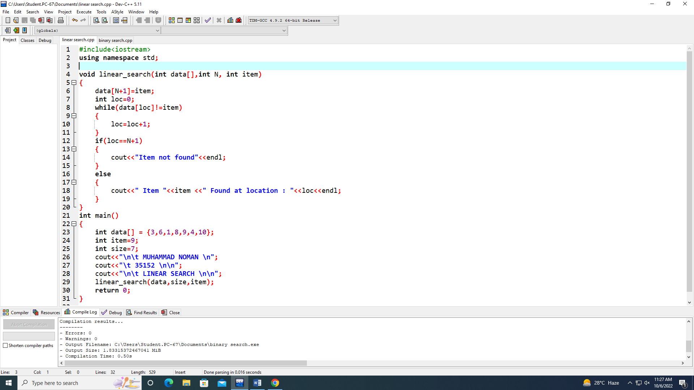

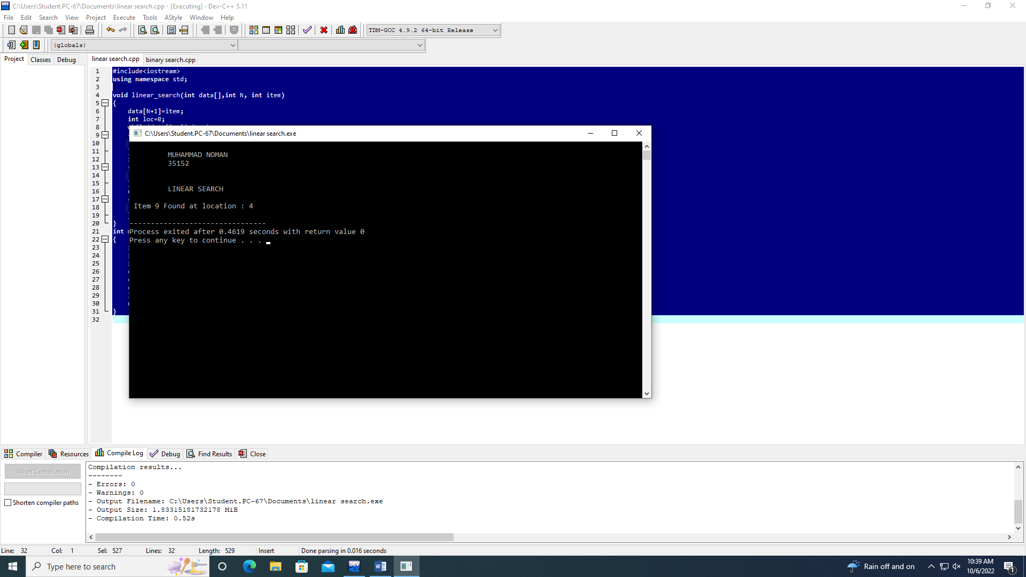

**TASK-2**

**BINARY SEARCH**

